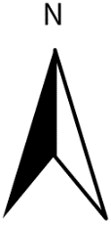
Envertech Microinverter Installation Map
Line 1
Line 2
Line 3
Line 4
Line 5
Line 6

